CSC 271 Data Structures
Assignment 2: Implementing a Stack Using a Compile-Time Array
Suppose that some application requires using two stacks whose elements are of the same type. A natural storage structure of such a two-stack data type would consist of two arrays and two top pointers. A better storage structure for a two-stack data type would be to use a single array for the storage structure and let the stacks grow towards each other.
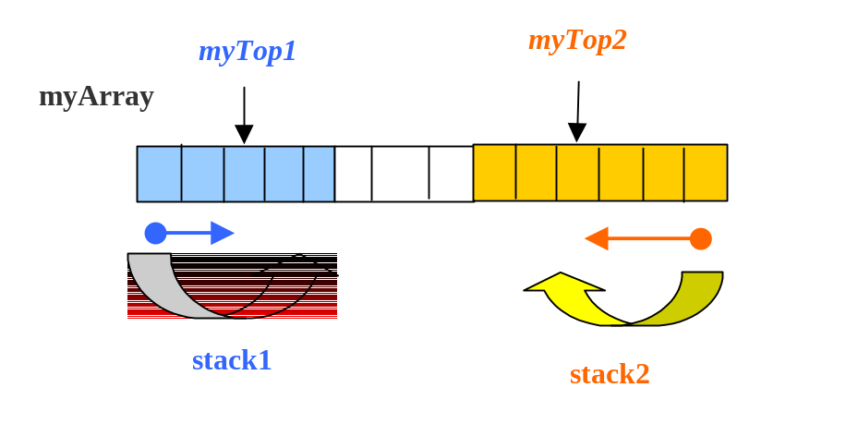
- Design a class DoubleStack for this two-stack data type using this implementation. In your functions for the basic stack operations, the number of the stack to be operated upon, 1 or 2, should be passed as a parameter. Also, the push operation should not fail because of a stack-full condition until all locations in the storage array have been used.
- Given the following specification of the top operation:
ItemType Top
Function: Returns copy of the last item put onto the stack.
Precondition: Stack is not empty.
Postconditions: Function value = copy of item at top of stack. Stack is not changed.

- Write the function top as a non- member function of the DoubleStackType.

- Implement the following operation as a member function of the above class DoubleStack.

replace(ItemType oldItem, ItemType newItem)
Function: Replaces all occurrences of oldItem with newItem.
Precondition: Stack has been initialized.
Postconditions: Each occurrence of oldItem in stack has been changed to newItem.

- Write the function replace(ItemType oldItem, ItemType newItem) as a new member function of class DoubleStack.
- Write the prototype and the definition of the same function as a non-member function of DoubleStack.

- Implement the following operation as a member function of DoubleStack class.

bool identical(DoubleStack& stack1)
Function: Determines if stack1 and self are identical.
Precondition: stack1 and self have been initialized.
Postconditions: stack1 and self are unchanged. Function value = (self and stack1 are identical).

- Write the function bool identical(DoubleStack& stack1) ) as a new member function of DoubleStack.

- Write the prototype and the definition of the same function as a non-member function of DoubleStack.

- Write a member function display to output the values stored in the DoubleStack.

- Write a test driver (.cpp) file to test all member functions.

What to submit
- The .h file
- The test driver file
- The output of the test driver

